Lab1: In-class activity
Mark:10

Introduction to Packet Tracer

Note: Lab 1 has been divided into two parts. In Lab 1 (part 1), you will familiarize yourself with the PT screens, parts, desktop tabs, add modules, use the simulator, and more. In Lab 1 (part 2 Intro to PT), you will run a pre-designed PT, learning about the device connections (cables)

Learning Objectives:
- Explore Packet Tracer Real-time mode
- Explore the Logical Workspace
- Explore Packet Tracer operation
- Connect devices (cables)
- Add modules to routers
- Examine a device configuration
- Ping, Ipconfig /all commands
Note: You should have downloaded and installed Packet Tracer (PT) from pre-lab1. Pay attention to the terminology and steps you are going through in this lab. During the demo for each lab, you will be questioned, as well as during the upcoming quizzes and exams. Remember, always save your PT for future use.
Log in to PT and set up two networks

When you try to open PT for the first time, it will ask you to log in or sign in to the Network Academy. Click on the blue tab (Networking Academy) and log in with your Algonquin College credentials (username and password).

Note: Sometimes, the blue tab does not work. Please click on the green tab and log in to the PT page.
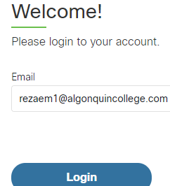
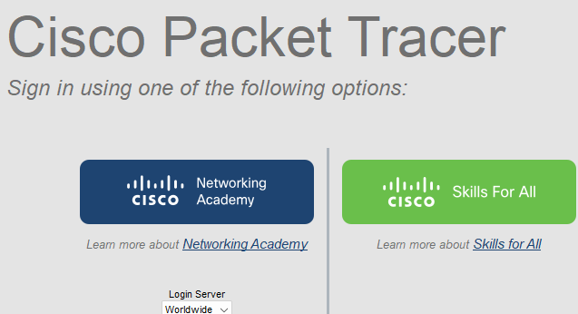

PT Background:
The simulator that is used in this course is Packet Tracer. Packet Tracer is a supplement, not a replacement for experience with real equipment. This activity will allow exploring the standard lab setup using the Packet Tracer simulator. Packet Tracer has two file formats it can create: .pkt files (network simulation model files) and .pka files (activity files for practice). When you create your networks in Packet Tracer or modify existing files from your instructor or your peers, you will often use the .pkt file format. When you launched this activity from the curriculum, these instructions appeared. They are the result of the. PKA, Packet Tracer activity file format.

Lab 1 part 1: Overview of the devices
The standard lab setup will consist of one router, two switches, and four PCs. Each of these devices will be set up and configured manually by you. Such information as device names, IP addresses, gateways, and connections.

Logical Workplace
When Packet Tracer starts, it presents a logical view of the network in real-time mode. The main part of the PT interface is the Logical Workplace. This is the large area where devices are placed and connected.
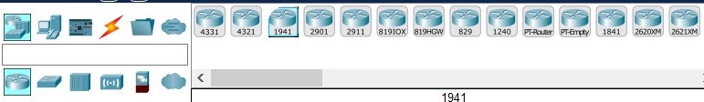

Symbols Navigation
The lower left portion of the PT interface, below the yellow bar, is the portion of the interface that you use to select and place devices into the logical workplace. The first box in the lower left contains symbols that represent groups of devices. As you move the mouse pointer over these symbols, the name of the group appears in the text box in the center. When you click on one of these symbols, the specific devices in the group appear in the box to the right. As you point to the specific devices, a description of the device appears in the text box below the specific devices. Click on each of the groups and study the various devices that are available and their symbols.

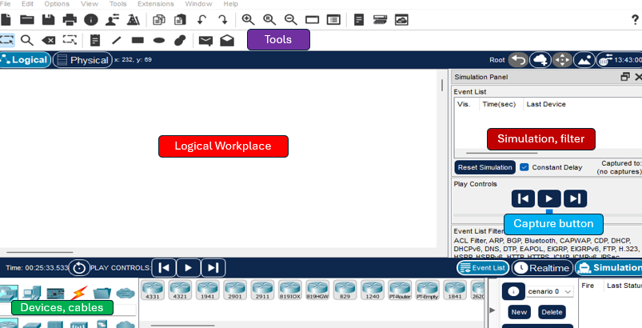

Choosing end devices, an intermediary, and cables to set up a physical topology
End devices: PC, servers, printers, mobile devices
Intermediary: Switches, routers

1-At the bottom of the screen, highlight the router icon, choose router 1941, and drag it to the Logical workplace (white area-router0)

2-Highlight the switch icon, choose two 2960-24TT (switch0 and switch1), and drag them to the Logical workplace one by one.

3-Highlight the end device icon, choose PC, and drag 4 PCs (0 to 3) into the Logical workplace.

How to delete or rename devices
Sometimes, you need to delete or rename a device in PT. There are two options for deleting or renaming devices:

Deleting device icon:

First, click on any device and drag it to the Logical workplace. PT always names the device from zero (0), like PC0, Switch0, Router0, and so on. If you want to delete a device, click on the delete icon, and your mouse becomes an X. Click on the device and delete it. You can delete any device or lines (cables) this way. Now, click on the Logical tab, and your mouse changes to an arrow again.

Renaming a device icon:

- You can rename the devices by clicking on the device’s name, such as Switch0 or Router0, PC0, and renaming it.
- Choose a device, click on Place a Note, and rename the device.
Click on PC0 once, rename it to PC1. Now, make sure all devices have the renamed according to the topology diagram before you continue.
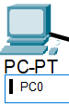
What is topology? _____________

Topology diagram
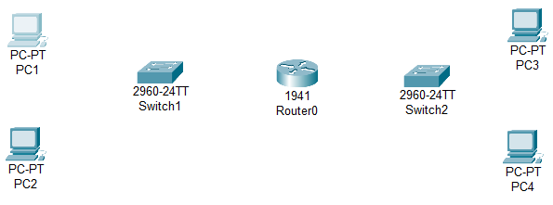

Make sure all devices have names
According to this topology

PT device connections: (cables)

There are four types of cables in PT:

Straight-through is used for connecting two different devices, like a PC to a switch or a router to a switch.

Crossover is used for connecting the same devices, such as a switch to switch, PC to PC, router to router, PC to router, and server to router. _ _ _ _ _ _
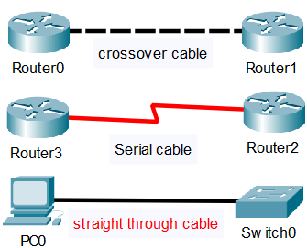

Serial cable: used to connect routers or devices to the internet, or Point-to-point routers

Roll-over cable: a proprietary cable used to manage and set up the Cisco routers.
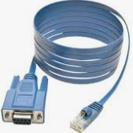
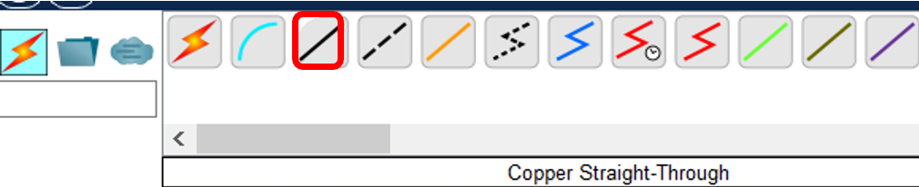

1-Click on the solid line / (forward slash). Your mouse becomes like a hammer. You will see PC1 with the FastEthernet0 port. Drag the hammer to switch1 and choose the first FastEthernet 0/1.
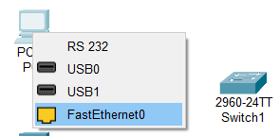

2-Repeat this step for the PC2, FastEthernet0 to FastEthent 0/2 on switch1
- Connect switch1 to router0. From switch1, find FastEthernet 0/10, click on router0, choose GigabitEthernet0/0.

Now do the same connections for the PC3, PC4, switch2, and router0

Pc3: FastEthernet0 to swtich2, port FastEtherner0/1

PC4: FastEthernet0 to swtich2, port FastEtherner0/2

Switch2: FastEthernet0/10 to router0, port GigabitEthernet0/1

How to add Modules or serial ports to the 1941 router

Some Cisco routers, such as 1941, do not have a serial connection; therefore, you must add the hardware (modules) to the device manually.

1-Click on the router0. Notice there are two black boxes (empty modules)
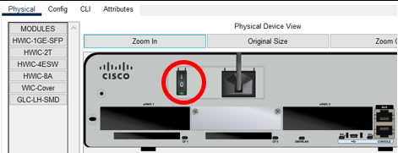

2-Double-click on router0 1941, choose the physical tab, and then click on the HWIC-2T tab. You will see a module at the bottom right of the screen
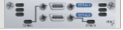

3-Click on the power button and shut down the router.

4- Drag and drop the module into the left slot first (Module 1), and again, drag the second module to the right slot. (Module 2)

5- Turn on the router again.
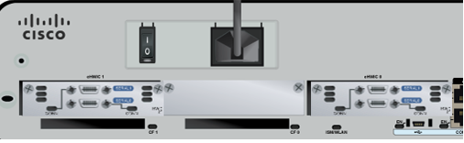

6-Click on the config tab. Now

You will see the serial ports (serial 0/0/0) in the router added. (right picture)
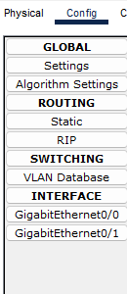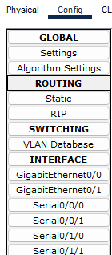

Implementing static IP addresses on all PCs and router0

First network (left)

1- Click on the PC1, choose the Desktop tab, and then click on the IP Configuration icon. Make sure the static radio button is highlighted.

Explanation:

IP address: identifies a host on a network

Subnet mask: specifies the network portion of a host.

Default gateway: It is the IP address of the router’s interface
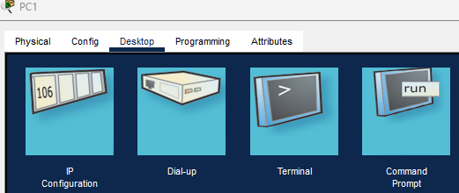

PC1:

Enter IPv4 address: 192.168.1.1
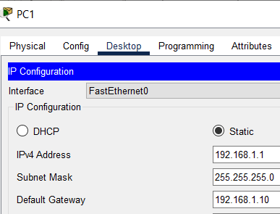

Subnet mask: 255.255.255.0

Default gateway: 192.168.1.10

Click on X to save the settings.

PC2:

IPv4 address: 192.168.1.2

Subnet mask: 255.255.255.0

DG: 192.168.1.10

Router 0:

Click on router 0, choose the config tab, and under the Interface,

choose GigabitEthernet0/0.

IPv4 address: 192.168.1.10 Subnet mask: 255.255.255.0

Check the on box (to turn on the router’s port). The triangle between router0 and switch2 in PT becomes green.
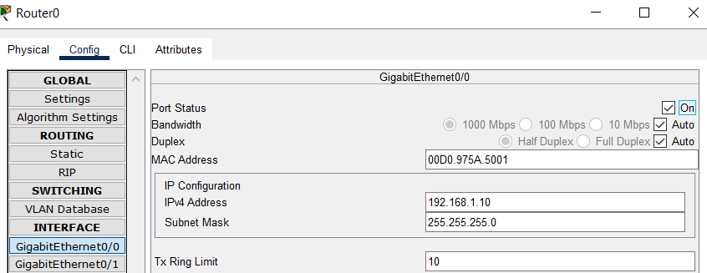

Second network: (right)

PC3:

IP address: 192.168.5.3

Subnet mask: 255.255.255.0

DG: 192.168.5.10

PC4:

IP address: 192.168.5.4

Subnet mask: 255.255.255.0

DG: 192.168.5.10

Router 0:

GigabitEthernet0/1: 192.168.5.10

Subnet mask: 255.255.255.0

Check the box on to turn on the router’s interface.

Notice that the triangles between router0 and switches are RED. That is because the interfaces (ports) on router0 do not have an IP address yet. As soon as you configure the IP address for the interfaces, the triangles become GREEN. The switch does not need any IP addresses at this time.
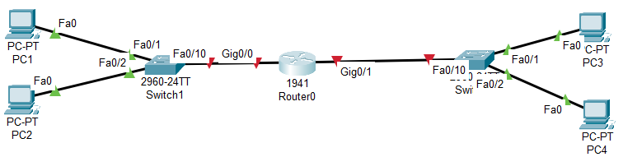

Test the device's connectivity.

Ping is a command or utility to test device connectivity with an IP address.

Ipconfig /all is a command or utility that shows the device's IP address, subnet mask, default gateway, physical address (MAC), DNS, DHCP, and so on.

1-Click on PC1, choose the command prompt tab, and ping PC2, type: ping 192.168.1.2, and press enter.

Insert the Screenshot here

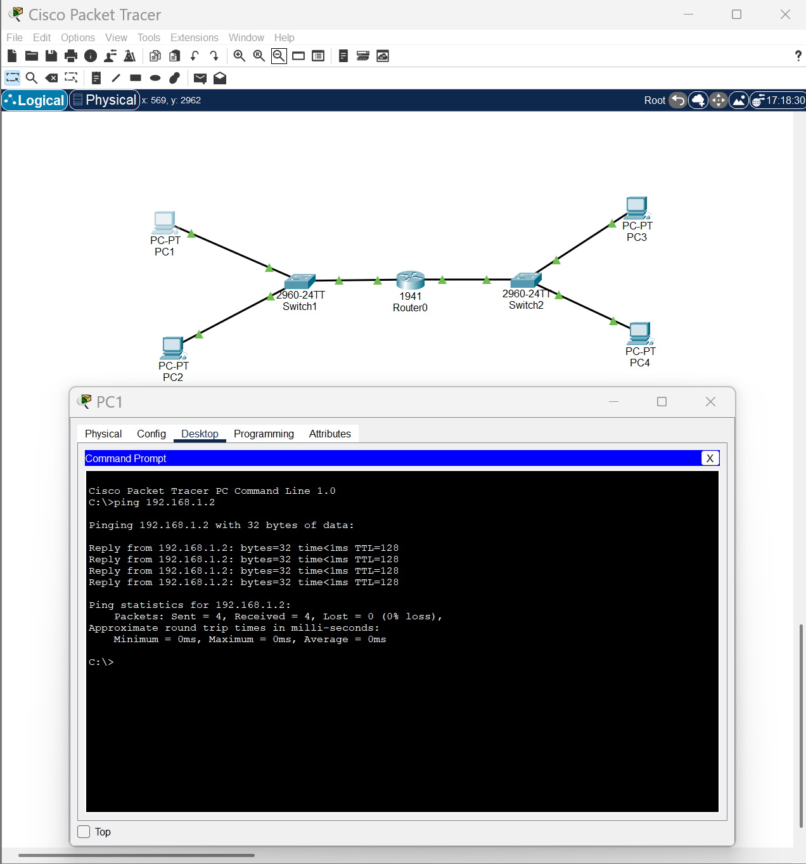

You should see 4 TTL (Time To Live messages. That means PC1 and PC2 are connected.

2- Do the same thing, ping PC3 to PC4. The result should be the same. All PCs should be able to ping each other. Ping PC3 from PC1.

Save the PT with a lab1-your-name example: lab1-mike-rezae

How to use the simulation tab in PT

1-Click on the simulation tab at the bottom right and choose Edit filter

2-Uncheck all the boxes except ARP and ICMP
3-Click on the Realtime tab, click on Add simple PDU
(Envelope on the top) and drag it on PC1 and then on PC3.
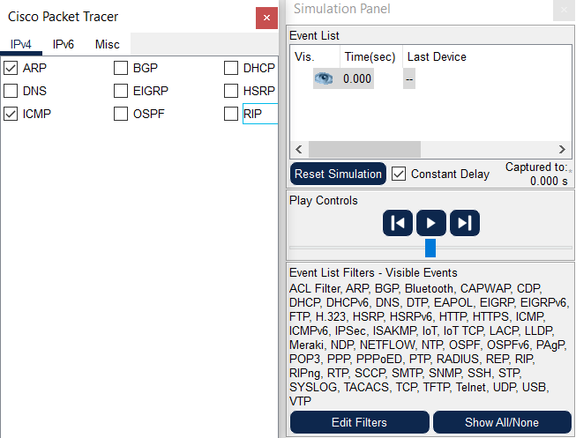


4-Click on PC1, go to the command prompt tab, and
Ping PC4, ping 192.168.5.4
5-Click on the simulation tab and click on the play button to capture
PDU (Protocol Data Unit)
6-Click on || (pause) to stop the simulation.
7-Click on any PDU packet and examine it. Check the OSI model and Inbound PDU Details tabs for the packet details.
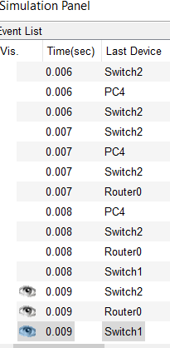

OSI Model tab:

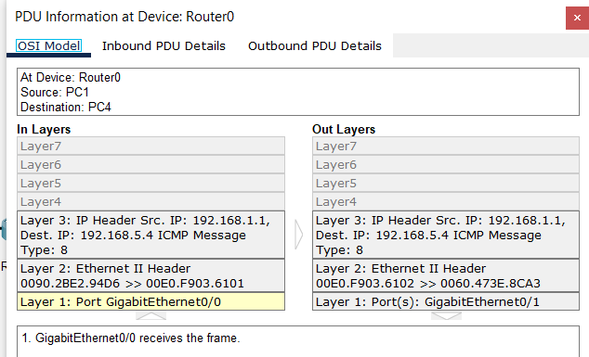
Inbound PDU Details tab:

You have completed your Packet

Tracer Lab 1 part 1

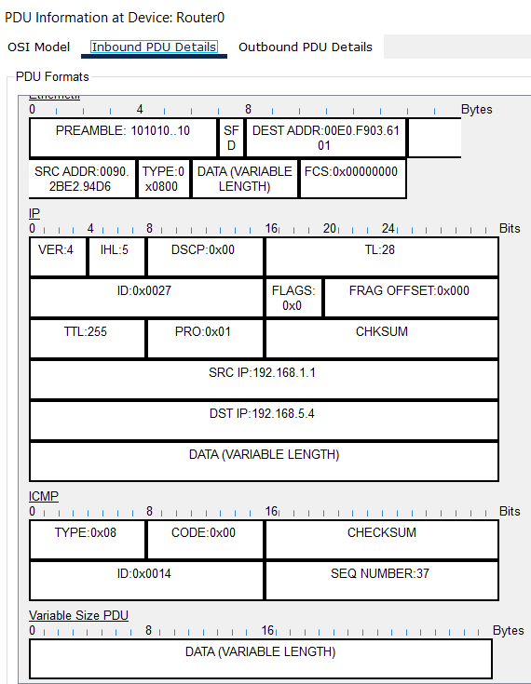

Now go to part 2 (Intro to PT file)

